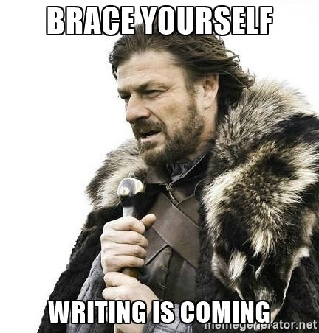
De Nieuwste School | Writing Portfolio mavo 4

Introduction:

This is the start of your writing portfolio. In this document you will find tasks which you, eventually, have to hand in.
You will find five different writing exercises. You have to write about 150 words for every exercise. The purpose of these exercises is to improve your writing. The reason to improve your writing is because of the upcoming writing test in test week 2. Moreover it is extremely useful when you’re able to write correct English in your further (academic) life.
If you have any questions about this reader, please let us know.
Kind regards,
Your teachers

Contents:

Introduction: 1
Assessment: 3
Normering: 4
Assignment One: 5
Schrijfruimte: 6
Assignment Two: 7
Schrijfruimte: 8
Assignment Three: 9
Schrijfruimte: 10
Assignment Four: 11
Schrijfruimte: 12
Assignment Five: 13
Schrijfruimte: 14

Assessment:
Op je schrijf PTA krijg je een beoordeling, en cijfer, op basis van het onderstaande model. Tijdens het oefenen in dit portfolio is het handig om dit model naast je werk te houden zodat je weet hoe je het doet. Ook zal je expert je opdrachten willen bekijken en voorzien van feedback, die je vervolgens kunt gebruiken om je andere werk te verbeteren.

Beoordelingsmodel Cito ERK-niveau A2:

Criterium | Beoordelingstaak | Score
Grammaticale correctheid | Beoordeel  • zinsbouw  • toepassing grammaticale regels | De tekst is (vrijwel) helemaal correct. 8 pt  De tekst is voldoende correct. 6 pt  De tekst is redelijk correct. 4 pt  De tekst is matig correct. 2 pt  De tekst zit vol fouten. 0 pt
Spelling, interpunctie | Beoordeel  • spelling  • gebruik hoofd- en kleine letters  • gebruik interpunctie | Spelling, interpunctie en schrijfconventies zijn goed. 2 pt  Spelling, interpunctie en schrijfconventies zijn voldoende. 1 pt  Spelling, interpunctie en schrijfconventies zijn onvoldoende. 0 pt
Woordgebruik | Beoordeel of de woordkeus accuraat is en gevarieerd | Het woordgebruik past goed bij de opdracht en ontstijgt soms dat niveau. 3 pt  Het woordgebruik sluit voldoende aan bij de opdracht. 2 pt  Het woordgebruik sluit maar matig aan bij de opdracht. 1 pt  Het woordgebruik schiet te kort voor de opdracht. 0 pt
Coherentie en cohesie | Beoordeel of de tekst goed is gestructureerd. | De opbouw van de tekst is, gezien de opdracht, goed. 2 pt  De opbouw van de tekst is, gezien de opdracht, voldoende. 1 pt  De opbouw van de tekst is, gezien de opdracht, onvoldoende. 0 pt

Normering:
Nadat je werk is beoordeeld met bovenstaand beoordelingsmodel, komt je cijfer als volgt tot stand.
Schaallengte: |  |  |  |  | 15
Normeringsterm: |  |  |  |  | 0,6
Score | Cijfer | #### | Score |  | Cijfer
0 | 1,0
1 | 1,3
2 | 1,8
3 | 2,4
4 | 3,0
5 | 3,6
6 | 4,2
7 | 4,8
8 | 5,4
9 | 6,0
10 | 6,6
11 | 7,2
12 | 7,8
13 | 8,4
14 | 9,0
15 | 10,0

Assignment One:
Story starter.
Finish the story. Write a plot and an ending in about 150 words.
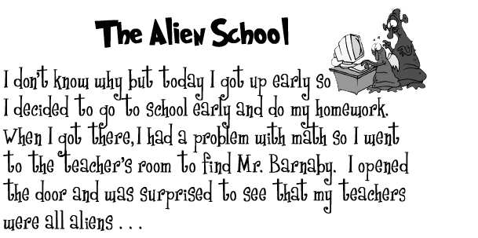
The Alien School
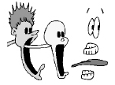
I don’t know why but today I got up early so I decided to go to school early and do my homework. When I got there I had a problem with math so I went to the teacher’s room to find Mr. Barnaby. I opened the door and was surprised to see that my teachers were all aliens …

Source: http://bogglesworldesl.com

Schrijfruimte:
__________________________________________________________________________________________________________________________________________________________________________________________________________________________________________________________________________________________________________________________________________________________________________________________________________________________________________________________________________________________________________________________________________________________________________________________________________________________________________________________________________________________________________________________________________________________________________________________________________________________________________________________________________________________________________________________________________________________________________________________________________________________________________________________________________________________________________________________________________________________________________________________________________________________________________________________________________________________________________________________________________________________________________________________________________________________________________________________________________________________________________________________________________________________________________________________________________________________________________________________________________________________________________________________________________________________________________________________________________________________________________________________________________________________________________________________________________________________________________________________________________________________________________________________________________________________________________________________________

Assignment Two:
Choose four numbers from 1 to 10.
1.
2.
3.
4.

Each number corresponds to an item on the list below. The first number is the character your story is to focus on, the second number is the setting for your story and the third concerns time. The fourth focuses on the situation/challenge. The character that you have chosen should be the main character of the story, but is not necessarily the ONLY character in the story. Likewise, most of the story will take place in the setting that you have chosen. The situation/challenge that you have chosen may involve the main character or your main character may observe someone else who must deal with this situation/challenge. You can combine the elements anyway you desire. Be sure all four elements are included in your story.
SITUATION
Write a story with the character, setting, time period and situation/challenge chosen.
ELEMENTS
Character: | Time:
1. a new mother | 1. after a fight
2. a photographer | 2. the night of high school graduation
3. a recent high school graduate | 3. after a big meal
4. a restaurant owner | 4. during a concert
5. a murderer | 5. late at night
6. a musician | 6. first week of the school year
7.a homeless child | 7. after a big thunderstorm has passed
8. an alien from outer space | 8. 1953
9. a lover | 9. 2020
10. a 93- year- old woman | 10. a hot summer day

Setting: | Situation/Challenge:
1. a wedding reception | 1. an important decision needs to be made
2. a concert hall | 2. someone feel like giving up
3. an expensive restaurant | 3. something embarrassing has just happened
4. a desolated castle | 4. someone has just reached an important goal
5. a party | 5. reminiscing on how things have changed
6. a library | 6. someone has found or lost something
7. Central London | 7. a death has occurred
8. a bedroom | 8. a secret needs to be confessed
9. a classroom | 9. someone’s pride has been injured
10. a pub | 10. someone has been accused of doing wrong

Schrijfruimte:
____________________________________________________________________________________________________________________________________________________________________________________________________________________________________________________________________________________________________________________________________________________________________________________________________________________________________________________________________________________________________________________________________________________________________________________________________________________________________________________________________________________________________________________________________________________________________________________________________________________________________________________________________________________________________________________________________________________________________________________________________________________________________________________________________________________________________________________________________________________________________________________________________________________________________________________________________________________________________________________________________________________________________________________________________________________________________________________________________________________________________________________________________

Assignment Three:
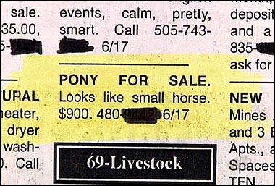

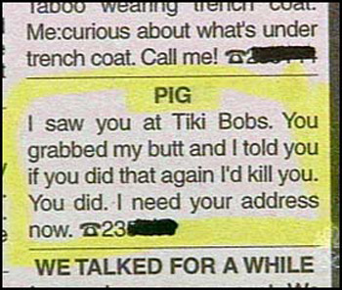
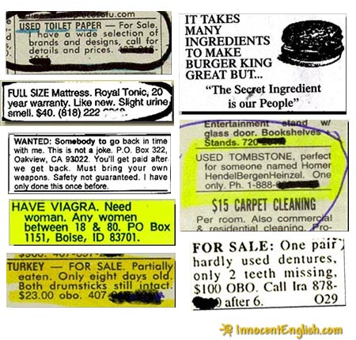
Choose one of the following eleven advertisements. Then do the exercise.

TITLE:
(Above the title you put a copy of the advertisement.) There are no real rules. Don’t make it too long. Many titles are just one word.
STORY
In your story the following questions must be answered:
- Who wrote the ad? (man, woman, age)
- What was the writer’s motivation (beyond buying/selling this specific item)?
- What kind of life does the writer have?
- What is the social setting behind the ad?
- What kind of family or community is involved?

SPECIFIC TOOLS ON PLOT
- Begin with an compelling first paragraph or lead, enough to grab the readers and make them curious to know what happens next.
- Make sure your plot works - there must be a beginning, a middle and an end.
- But don’t spend too much time on the build-up, so that the climax is relegated to one sentence, leaving the reader bothered and bemused but not bewitched.
- Don't reveal the twist ending too soon - try to keep the reader guessing until the last moment.
- If you’re writing a fast-moving story (e.g. crime) keep your paragraphs and sentences short.

Schrijfruimte:
__________________________________________________________________________________________________________________________________________________________________________________________________________________________________________________________________________________________________________________________________________________________________________________________________________________________________________________________________________________________________________________________________________________________________________________________________________________________________________________________________________________________________________________________________________________________________________________________________________________________________________________________________________________________________________________________________________________________________________________________________________________________________________________________________________________________________________________________________________________________________________________________________________________________________________________________________________________________________________________________________________________________________________________________________________________________________________________________________________________________________________________________________________________________________________________________________________________________________________________________________________________________________________________________________________________________________________________________________________________________________________________________________________________________________________________________________________________________________________________________________________________________________________________________________________________________________________________________________

Assignment Four:
Pre-writing activity:
Decide upon a historical character. Find information about this person. Choose one of these characters:
From left to right: Neptune, Chief Joseph, Buffalo Bill, Charles Darwin, Nostradamus, Isaac Newton, Copernicus, Graham Bell, Beethoven, Aladdin, Ghandi, Quasimodo, Emperor Qin, Cleopatra, Damo, Confucius, Stamford Raffles, Galileo Galilei, Thomas Edison, Albert Eindstein, Pocahontas, John Rolfe, Genghis Khan, Marco Polo, Orville Wright, Wilbur Wright, Vlad Dracula.
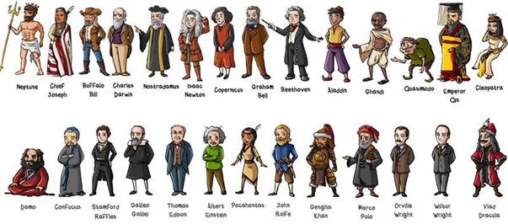
Title
This will be the name of the chosen historical character.
STORY
Choose one of the following sentence beginnings below, and complete the sentence for your figure. Compose a short story in first-person, speaking as the historical figure. Explain the figure's wish, dream, or fear.

The thing that I regret most about my life is _____________________.
If I could accomplish one more thing, I would ___________________.
The accomplishment that I am proudest of is ___________________.
If I could live anywhere in the world, I would choose ______________.
The saddest moment in life was when _________________________.
My favorite childhood memory is _____________________________.
The thing that scares me the most is __________________________.

SPECIFIC TOOLS ON PLOT
- Begin with an interesting first paragraph or lead, enough to grab the readers and make them curious to know what happens next. Start with a sentence beginning above.
- Make sure your plot works - there must be a beginning, a middle and an end.
- But don't spend too much time on the build-up, so that the climax is relegated to one sentence, leaving the reader bothered and bemused but not bewitched.
- Don't reveal the twist ending too soon - try to keep the reader guessing until the last moment.

Schrijfruimte:
____________________________________________________________________________________________________________________________________________________________________________________________________________________________________________________________________________________________________________________________________________________________________________________________________________________________________________________________________________________________________________________________________________________________________________________________________________________________________________________________________________________________________________________________________________________________________________________________________________________________________________________________________________________________________________________________________________________________________________________________________________________________________________________________________________________________________________________________________________________________________________________________________________________________________________________________________________________________________________________________________________________________________________________________________________________________________________________________________________________________________________________________________

Assignment Five:
Story starter.
Finish the story. Write a plot and an ending in about 150 words.

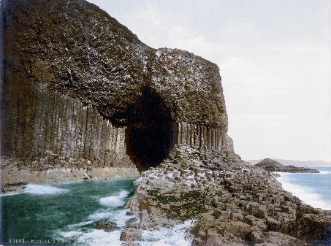
The Cave
I was standing in front of the cave´s entrance. Around the cave, there were seven different signs warning people to keep out. I wondered what could be in there. I had a flash light so …

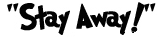


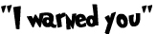
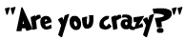


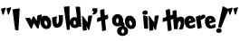

Source: www.bogglesworldesl.com

Schrijfruimte:
__________________________________________________________________________________________________________________________________________________________________________________________________________________________________________________________________________________________________________________________________________________________________________________________________________________________________________________________________________________________________________________________________________________________________________________________________________________________________________________________________________________________________________________________________________________________________________________________________________________________________________________________________________________________________________________________________________________________________________________________________________________________________________________________________________________________________________________________________________________________________________________________________________________________________________________________________________________________________________________________________________________________________________________________________________________________________________________________________________________________________________________________________________________________________________________________________________________________________________________________________________________________________________________________________________________________________________________________________________________________________________________________________________________________________________________________________________________________________________________________________________________________________________________________________________________________________________________________________

